**4 GIT About It**

**Project Concept Document**

Our project will consist of a web application that allows for 4 different learning constructs:

1) traditional math problems

2) worded math problems

3) sudoku logic puzzles

4) Geometry.

Each problem will be worth a certain number of points depending on the difficulty and the object of the game is to be the first person to score 100 points. The overall idea with this web application is that it will not only teach kids to solve basic addition and subtraction problems and word problems quickly, but also solve logical puzzles: Developing logic skills early can help children become better at computer programming.

The basic math equations will look something like 5 + 12 = ? or 10 + 15 = ?

The word problems will be simple word problems like I have 5 cats and 2 dogs. How many pets do I have? OR I have 6 apples and give you two apples. How many apples do I now have?

This is a basic example of the Sudoku math logic puzzle.

|  |  |  |  |
| --- | --- | --- | --- |
| 1 | 2 | 3 | 4 |
| 3 | 2+2 | 2 | 1 |
| 4 | 3 | 1 | 2 |
| 2 | 1 | 4 | 3 |

Sudoku is a grid based logic game where you need to fill in the blank squares with numbers. In this example the numbers need to be either 1, 2, 3, or 4.

|  |  |
| --- | --- |
|  | 2 |
| 3 | 4 |

The numbers cannot be repeated horizontally or vertically.

|  |  |
| --- | --- |
| 2 | 2 |
| 3 | 4 |

|  |  |
| --- | --- |
| 3 | 2 |
| 3 | 4 |

In the larger grid, you will have a 4x4 grid made up of 2x2 grids, like this:

|  |  |  |  |
| --- | --- | --- | --- |
| 1 | 2 | 3 | 4 |
| 3 | 4 | 2 | 1 |
| 4 | 3 | 1 | 2 |
| 2 | 1 | 4 | 3 |

In each 2x2 grid you will have to enter the numbers 1, 2, 3, or 4. The numbers cannot repeat within the 2x2 grid, as well as the other 2x2 grids next to it. Here are some examples.

|  |  |  |  |
| --- | --- | --- | --- |
| 1 | 2 | 3 | 4 |
| 3 | 2 | 2 | 1 |
| 4 | 3 | 1 | 2 |
| 2 | 1 | 4 | 3 |

|  |  |  |  |
| --- | --- | --- | --- |
| 1 | 2 | 3 | 4 |
| 3 | 4 | 2 | 3 |
| 4 | 3 | 1 | 2 |
| 2 | 1 | 4 | 3 |

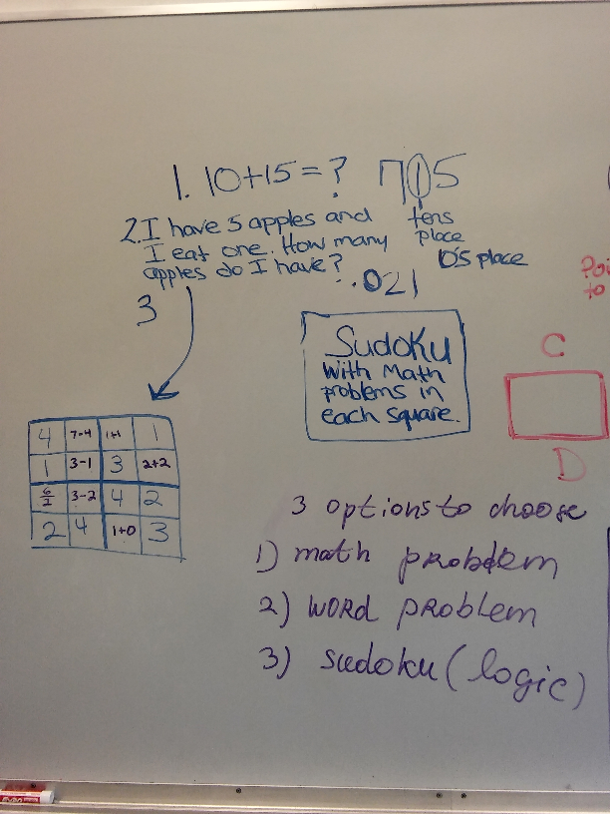

In geometry, we can have the students match the shapes, have them color same shapes from a pile of different shapes.

